|  |  |
| --- | --- |
| **Ex. No. 7** | **JQuery** |
| **Date of Exercise** | **12/10/2022** |
| **Web Host Link** |  |
| **Youtube Link** | https://drive.google.com/file/d/1urV7s5l7fo6sDVV2YXnFb1R1w0CnXHJl/view?usp=share_link |

**Aim :** To create web pages using various JQuery Effects, Elements and traversing in Jquery

# Description :

## Add Element :

* append() - Inserts content at the end of the selected elements
* prepend() - Inserts content at the beginning of the selected elements
* after() - Inserts content after the selected elements
* before() - Inserts content before the selected elements

## Remove Elements

* remove() - Removes the selected element (and its child elements)
* empty() - Removes the child elements from the selected element

## Traversing

* he <div> element is the **parent** of <ul>, and an **ancestor** of everything inside of it
* The <ul> element is the **parent** of both <li> elements, and a **child** of <div>
* The left <li> element is the **parent** of <span>, **child** of <ul> and a **descendant** of <div>
* The <span> element is a **child** of the left <li> and a **descendant** of <ul> and <div>
* The two <li> elements are **siblings** (they share the same parent)
* The right <li> element is the **parent** of <b>, **child** of <ul> and a **descendant** of <div>
* The <b> element is a **child** of the right <li> and a **descendant** of <ul> and <div>

**JQuery Effects:**

|  |  |
| --- | --- |
| **Method** | **Description** |
| animate() | Runs a custom animation on the selected elements |
| clearQueue() | Removes all remaining queued functions from the selected elements |
| delay() | Sets a delay for all queued functions on the selected elements |
| dequeue() | Removes the next function from the queue, and then executes the function |
| fadeIn() | Fades in the selected elements |
| fadeOut() | Fades out the selected elements |
| fadeTo() | Fades in/out the selected elements to a given opacity |
| fadeToggle() | Toggles between the fadeIn() and fadeOut() methods |
| finish() | Stops, removes and completes all queued animations for the selected elements |
| hide() | Hides the selected elements |
| queue() | Shows the queued functions on the selected elements |
| show() | Shows the selected elements |
| slideDown() | Slides-down (shows) the selected elements |
| slideToggle() | Toggles between the slideUp() and slideDown() methods |
| slideUp() | Slides-up (hides) the selected elements |
| stop() | Stops the currently running animation for the selected elements |
| toggle() | Toggles between the hide() and show() methods |

# Question 1 :

Car moving animation using Jquery

# Program :

<!DOCTYPE html>

<html>

    <head>

        <title>Moving Car</title>

        <meta charset="UTF-8">

        <meta http-equiv="X-UA-Compatible" content="IE=edge">

        <meta name="viewport" content="width=device-width, initial-scale=1.0">

        <title>Document</title>

        <script src="https://ajax.googleapis.com/ajax/libs/jquery/3.6.0/jquery.min.js"></script>

        <script>

        $(document).ready(function(){

            $(document).keydown(function(event){

                var car = $('#car')

                var arrow = {left: 37, up: 38, right: 39, down: 40 };

                switch(event.which){

                    case arrow.right: car.css('transform','rotate(360deg)');

                    car.animate({left:'+=5px'},1);

                    break;

                    case arrow.down: car.css('transform','rotate(90deg)');

                    car.animate({top:'+=5px'},1);

                    break;

                    case arrow.up:  car.css('transform','rotate(270deg)');

                    car.animate({top:'-=5px'},1);

                    break;

                    case arrow.left: car.css('transform','rotateY(180deg)');

                    car.animate({left:'-=5px'},1); break;

                }

                var car = $('#car');

                var car_pos = $('#car').position(); var l = car_pos.left;

                var t = car_pos.top;

                if (l > 0 && l < 268 ) { if(t < 85 || t >250)

                    {

                        $('#car').fadeOut('slow');

                        $('#car').fadeIn('slow');

                    }

                }

                if (l >470) {

                    if(t < 85 || t >250)

                    {

                        $('#car').fadeOut('slow');

                        $('#car').fadeIn('slow');

                    }

                }

            })

            })

            </script>

            <style>

            *{

                margin: 0px; padding: 0px;

                box-sizing: border-box;

            }

            .r1 {

                position: fixed;

                z-index: 0;

                top:0px;

                width: 200px;

                height: 800px;

                left: 40%;

                background-color: black;

            }

            .r2{

                position: fixed;

                top:100px;

                z-index: 1;

                width: 100%;

                height: 200px;

                background-color: black;

            }

            </style>

            </head>

            <body>

                <div id="car" style="position:absolute;z-index:3;left:5px; top:100px;width:80px;height:50px;">

                    <img id="car" src="Q1.jpg" alt="" width="80" height="50">

                </div>

                <br>

                <div class="r1"></div>

                <div class="r2"></div>

            </body>

            </html>

# Output :



# Question 2 :

Create a dynamic Registration form and display it in the same page using JQuery

1. Use Dom_get and dom_set to the set the values to the form
2. Dynamically add buttons and remove buttons
3. Use traversing function to display dynamically generated value in the result display portion

# Program :

<!DOCTYPE html>

<html>

    <head>

        <title>Registration Form</title>

        <h1>Registration Form</h1>

        <script src="https://ajax.googleapis.com/ajax/libs/jquery/3.6.0/jquery.min.js"></script>

        <style>

        .ancestors * { display: block;

            border: 2px solid rgb(0, 0, 0);

            color: rgb(40, 29, 29); padding: 5px;

            margin: 15px;

            }

            </style>

            <script>

            $(document).ready(function(){

                $("#add").click(function(){

                    $('#out').append("Name : " + $('#name').val() + "<br>Reg.No : " + $('#Reg').val() + "<br>");

                });

                $("#remove").click(function(){

                    $("#div").remove()

                });

                });

                </script>

                </head>

                <body>

                    Name :  &nbsp; &nbsp; <input type="text" id="name"><br><br>

                    Reg.No. : <input type="text" id="Reg"><br><br>

                    <div class="ancestors" id="div">

                        <p id="out"> </p>

                        </div>

                        <button id="add">Append text</button>

                        <button id="remove">Remove text</button>

                    </body>

                    </html>

# Output :

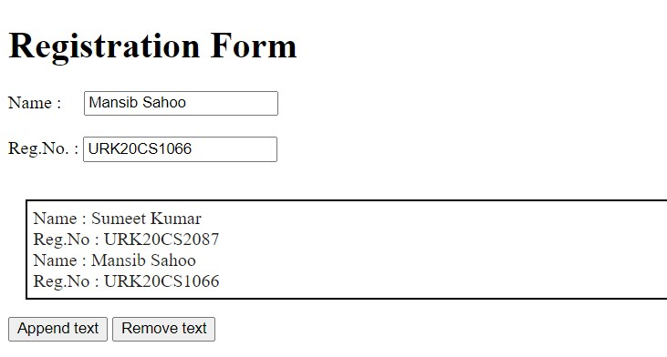

# Question 3 :

Create a car body workshop using JQuery where in you should be able to change the color of the car, glass tint, size of the tyres.

# Program :

<!DOCTYPE html>

<html>

    <head>

        <script src="https://ajax.googleapis.com/ajax/libs/jquery/3.6.0/jquery.min.js"></script>

        <meta name="viewport" content="width=device-width, initial-scale=1">

        <style>

        .trapezoid{

            border-bottom: 50px solid #555; border-left: 25px solid transparent; border-right: 25px solid transparent; height: 0;

            width: 125px;

        }

        .circle{

            height: 50px; width: 50px;

            background-color:rgb(0, 0, 0);

            border-radius: 50%; display: inline-block;

        }

        .rectangle{

            height: 50px; width: 250px;

            background-color: gold;

        }

        </style>

        <script>

        $(document).ready(function(){

            $("#body_col").click(function(){

                var red = Math.floor(Math.random()*255);

                var blue = Math.floor(Math.random()*255);

                var green = Math.floor(Math.random()*255);

                var color = "rgb("+red+","+green+","+blue+","+cornblue+","+purple+","+black+")";

                $("#body").css({"background-color": color, });

            });

            $("#tyre_size_increase").click(function(){

                size = "75%"

                h = "75px"

                w = "75px"

                $("#tyre1").css({"border-radius": size, "height": h, "width":

                w, })

                $("#tyre2").css({"border-radius": size, "height": h, "width":

                w, });;

            });

            $("#tyre_size_decrease").click(function(){

                size = "50%"

                h = "50px"

                w = "50px"

                $("#tyre1").css({"border-radius": size, "height": h, "width":

                w, })

                $("#tyre2").css({"border-radius": size, "height": h, "width":

                w, });;

            });

            });

            </script>

            </head>

            <body><h1>Trapezoid CSS</h1>

                <div class="trapezoid"></div>

                <div class="rectangle" id="body"></div>

                <div class="circle" id="tyre1"></div> &nbsp;&nbsp;&nbsp;&nbsp;&nbsp;&nbsp;&nbsp;

                &nbsp;&nbsp;&nbsp;&nbsp;&nbsp;&nbsp;&nbsp;&nbsp;&nbsp;&nbsp;

                &nbsp;&nbsp;&nbsp;&nbsp;&nbsp;&nbsp;&nbsp;&nbsp;&nbsp;&nbsp;&nbsp;&nbsp;

                <div class="circle"id="tyre2"></div><br>

                <button id="body_col">Body Colour</button>

                <button id="tyre_size_increase">tyre size increase</button>

                <button id="tyre_size_decrease">tyre size decrease</button>

            </body>

            </html>

# Output :

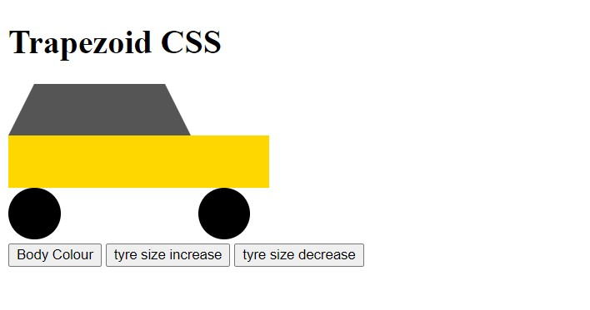

**Result:**

The above program is executed and verified successfully.